P.250 Problem 5.6

The matlab code of the problem is attached below. The plot and the results of the x_{i} ‘s of the first function (f(x) = x²-1=0) are as follows:
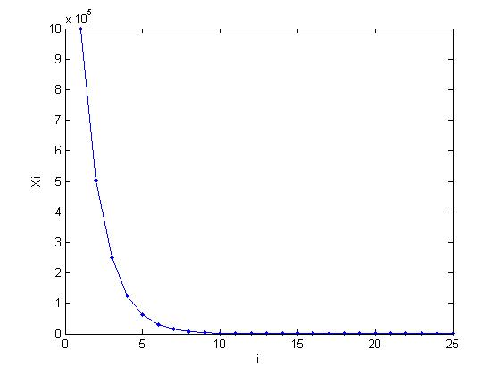
x =

1.0e+006 *

Columns 1 through 7

1.0000 0.5000 0.2500 0.1250 0.0625 0.0313 0.0156

Columns 8 through 14

0.0078 0.0039 0.0020 0.0010 0.0005 0.0002 0.0001

Columns 15 through 21

0.0001 0.0000 0.0000 0.0000 0.0000 0.0000 0.0000

Columns 22 through 25

0.0000 0.0000 0.0000 0.0000

From the 16th column, results seem to be 0; however it is only because of the representation of matlab. It rounds off the remaining digits for the displaying purposes. The correct values are also given below:

x(16) = 30.5285
x(17) = 15.2806
x(18) = 7.6730
x(19) = 3.9017
x(20) = 2.0790
x(21) = 1.2800
x(22) = 1.0306
x(23) = 1.0005
x(24) = 1.0000
x(25) = 1.0000

From the plot and the x_{i} values, it can be said that the apparent convergence rate of the sequence is initially linear. However, the asymptotic convergence rate of this function should be quadratic. A simple calculation is needed to find this:

f(x) = x²-1=0
x* = ±1
f’(x) = 2x
f’(x*) = ±2 ≠ 0

Since f(x*) = 0 but f’(x*) ≠ 0, we can conclude that the function has simple roots. Therefore, the asymptotic convergence rate of Newton’s method is quadratic for this equation. Asymptotic behavior of the function is reached after 21st iteration. These different results are observed because results of the asymptotic convergence rate of Newton’s method are local. The initial x₀ is not close enough to the root, and so quadratic behavior is not observed.

The plot and the results of the x_{i} ‘s of the second function (g(x) = (x-1)⁴ = 0) are as follows:
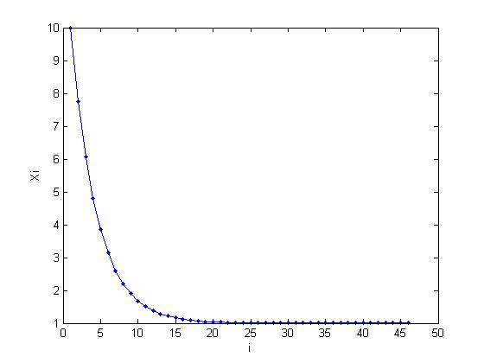

>> y

y =

Columns 1 through 7

10.0000 7.7500 6.0625 4.7969 3.8477 3.1357 2.6018

Columns 8 through 14

2.2014 1.9010 1.6758 1.5068 1.3801 1.2851 1.2138

Columns 15 through 21

1.1604 1.1203 1.0902 1.0677 1.0507 1.0381 1.0285

Columns 22 through 28

1.0214 1.0161 1.0120 1.0090 1.0068 1.0051 1.0038

Columns 29 through 35

1.0029 1.0021 1.0016 1.0012 1.0009 1.0007 1.0005

Columns 36 through 42

1.0004 1.0003 1.0002 1.0002 1.0001 1.0001 1.0002

Columns 43 through 46

1.0002 1.0001 1.0001 1.0001

We can inspect the results now. 1 appears in the first digit starting from the ninth element. 8 iterations should be made to find the first digit correctly. 0 appears in the first floating digit starting from the 17th element. Like the first digit 1, 8 additional iterations should be made to find the second digit of the root. The other digits of the root are found all in 8 iterations. Therefore, it can be said that the convergence of this sequence is linear.
The calculation method for finding this convergence rate is as follows:

g(x) = (x-1)⁴ = 0
x* = 1
g’(x) = 4*(x-1)³
g’(x*) = 0

g(x) and g’(x) are both 0. The root “1” is multiple.

C=1-1/m
m = 4 (multiplicity)
C = ¾

lim_{(k→∞)} |e_{k+1}|/|e_{k}|^{r} = C
If r is really 1, that is the convergence is linear, this equation must hold. For the elements in the sequence, this equation holds. Values of the constant for the sequence is given below: (k(1) is the division of the error in x₁ to the error in x₂).

k =

Columns 1 through 7

0.7500 0.7500 0.7500 0.7500 0.7500 0.7500 0.7500

Columns 8 through 14

0.7500 0.7500 0.7500 0.7500 0.7500 0.7500 0.7500

Columns 15 through 21

0.7500 0.7500 0.7500 0.7500 0.7500 0.7500 0.7500

Columns 22 through 28

0.7500 0.7500 0.7500 0.7500 0.7500 0.7500 0.7500

Columns 29 through 35

0.7500 0.7500 0.7500 0.7500 0.7499 0.7501 0.7515

Columns 36 through 42

0.7515 0.7511 0.7435 0.8322 0.7375 2.1834 0.7527

Columns 43 through 45

0.6350 0.7506 1.0000

These results show that x₀ for the second function is close enough to the real root, and so linear convergence rate is observed from the beginning of the sequence.

P.97 Exercise 2.2

We need to prove that one of the defining properties of nonsingular matrices does not hold.

An n x n matrix A is said to be nonsingular if for any vector z ≠ 0, Az ≠ 0.

Now, take an n x 1 matrix [1 1 1 … 1]^{T}. Multiply this matrix with A. The result must not be 0 if A is nonsingular. If we denote the elements of the matrix A as a₁₁,a₁₂,…,a_{1n},a₂₁,a₂₂,….,a_{nn} , the first index is the row number and the second index is the column number, one of the a_{i1}*1+a_{i2}*1+a_{i3}*1…+a_{in}*1 multiplications (i is starting from 1 and ends with n) must be different than 0. However, each of the row sums of the matrix A is equal to zero. Therefore, A must be a singular matrix.
Newton.m

function [sequence] = Newton(x0,fx,tolerance)
derfx=polyder(fx);
gx = x0 - polyval(fx,x0)/polyval(derfx,x0);
sequence = [x0,gx];
while abs(x0-gx)>tolerance
x0 = gx;
gx = x0 - polyval(fx,x0)/polyval(derfx,x0);
sequence = [sequence,gx];
end

Newtondemo.m

x = Newton(1000000,[1 0 -1],0.00001);
y = Newton(10,[1,-4,6,-4,1],0.00001);
for j=1:24
l(j) = (x(j+1)-1)/(x(j)-1);
end
for j=1:45
k(j) = (y(j+1)-1)/(y(j)-1);
end

